Adult Services Committee Meeting February 7, 2024
Chairpersons: Samantha Hurd, Micah Ennis, Tracie McMillan-Downer, Felissa Ferrell
Welcome: Micah Ennis called the meeting to order at 9:45 and and welcomed guests and participants.
Approval of January 11, 2024 minutes: Matthew Hillman motioned that we approve the January 11, 2024, meeting minutes. Debbie Green seconded, and the motion passed.
Presentation by: Kristi Nickodem, UNC School of Government-Confidentiality in Adult Protective Services
- This is tricky area in DSS. Confidentiality helps protect the dignity of the person.
- DSS confidentiality is the most challenging because we deal with so many different programs, including GS 108A-80 which speaks to DSS confidentiality, HIPAA, 42 CFR Part 2-federal substance abuse regulation, GS 122C-behavioral health. The laws “don’t speak to each other.”
- When can information be shared? With a client’s consent, pursuant to a court order, to provide services to the client to protect the client, to protect other and purpose of program administration. Rule of thumb: There’s always an exception. Ask these two questions:
Who wants it? And for what purpose?
- There are various sources of law: State general statute or federal laws; Rules and regulations through NC Administrative Code or through federal CFR and then through policy and guidance, which is not law but helps interpret how it can be applied.
- How these laws interact is; and overall you follow the more restrictive law. For example, if disclosure is prohibited by federal law and you cannot disclose the information, even if allowed by state law. If disclosure is prohibited by state law, you cannot disclose it, even if federal law says you can UNLESS disclosure is required by federal law, even if state law prohibits it.
- Overview of State Laws that are utilized in Adult Services: GS 108A-80, which applies to social services and public assistance programs. Program specific laws include APS-10A NCAC Subchapter 71A, GS 108A-116 (d). However, there are laws that are not specific to DSS that may apply, including GS 122C-51-56 for MH/DD/SUD facilities; 10A NCAC Subchapter 26B and GS 130A-143 communicable disease. Most of the APS rules are in NC Administrative Code.
- State Statutes and Rules: General Social Services: GS 108A-80 and 10A NCAC Chapter 69; for APS-GS 108A-116(d) (financial records); 10A NCAC Chapter 71A. Always remember to review Administrative code
- Exceptions to 108A-80 under chapter 10A NCAC 69
- Client consent
- Internal referrals/eligibility reviews/supervision
- To other county DSS or state DSS
- Research, as approved by DHHS
- To comply with court order or other laws
- Client right to access
- Federal, State, County staff for monitoring, auditing, evaluating or facilitating other state or federal programs.
- Client right to access-10A NCAC 69 .0301-upon written or verbal request, without being charged a copy of the record with exceptions:
  - Information that the agency is required to keep confidential by state or federal statutes, rules or regulations;
  - Confidential information originating from another agency; or
  - Information that would breach other individuals right to confidentiality under the state or federal statutes, rules, regulations
- The client is any applicant or recipient of public assistance or services; someone acting on behalf of the client in accordance with the right to act on the client’s behalf under a legal order
- There is heightened protection in APS reports around the identify of the reporter and can only be disclosed through court order, DHSR to carry out an investigation, or to DA or LEO on a specific investigation; specific findings including client consent, court order, as necessary to protect the adult, if APS evaluation indicates law violations and to NC DHHS for APS register; and any copies of the disabled adults financial records can only be disclosed per court order.
- Inter-County Cooperation in APS: if disabled adult moves to another county and consented for the information to be shared, the DSS providing protective services can share information to the new county DSS. DSS in new county must contact disabled adult and determine if further services are needed, with consent. If disabled adult does not consent; DSS providing protective services cannot share the information to the new county DSS. Consider-is there a need to make a new report?
- Inter-County Cooperation in APS with a court order-if client moves to another county; APS in first county may be made to new county without the client’s consent. DSS will file a motion in original county to be relieved of responsibility since adult is in a new county. If the second county requests information to conduct evaluation, first county shall provide the needed information.
- NCGS 122C Behavioral health protection for mental health, IDD and SUD, and is followed by providers, medical providers and anyone who has obtained confidential behavioral health information. Can be shared by court order, as required under Article 6 of GS 108A (APS) or Article 3 of GS 7B (CPS), patient consent, immeninet danger or providing EMS services
- Federal SUD Records Law 42 CFR Part 2-providers, and anyone who has this information. Can only be shared by patient consent, court order or medical emergency.
- Communicable disease- GS 130A-143; can give information if client consents, for purposes of complying with laws, court order or subpeona, for purposes of treatment,payment or healthcare operations.
- Who can access APS information? Mandatory report to DA office if finds evidence of A, N, or E. Or Director, under 10A NCAC 71A. 0201© tell DA or LEO where there is reason to believe physical harm could occur. Also, to the APS complainant (Reporter).
- Agencies meet HIPAA if they are a covered entity. They have a health care provider on staff or are a health care provider. And they are providing Medicaid billing. You can be a HIPAA Hybrid entity; some consolidate agencies that make that designation. See 2015 SOG Aimee Wall about HIPAA information.
Question: A clerk told an agency they cannot mention IVC or testify to it; Kristi will find out.
- When APS completes an evaluation in a facility, they need to complete a written summary to the administrator, but need to protect vital information, such as who was interviewed, what the allegations were, if substantiated and how they determined the conclusion. Also need to make a report to DHSR concerning the report if A, N, and E found even if evaluation is not completed, must send APS evaluation report to DHSR , must contact DHB and DHSR if APS finds exploitation in Medicaid funded facilities, and if licensure standards not met, must make report to appropriate section in DSHR or to AHS.
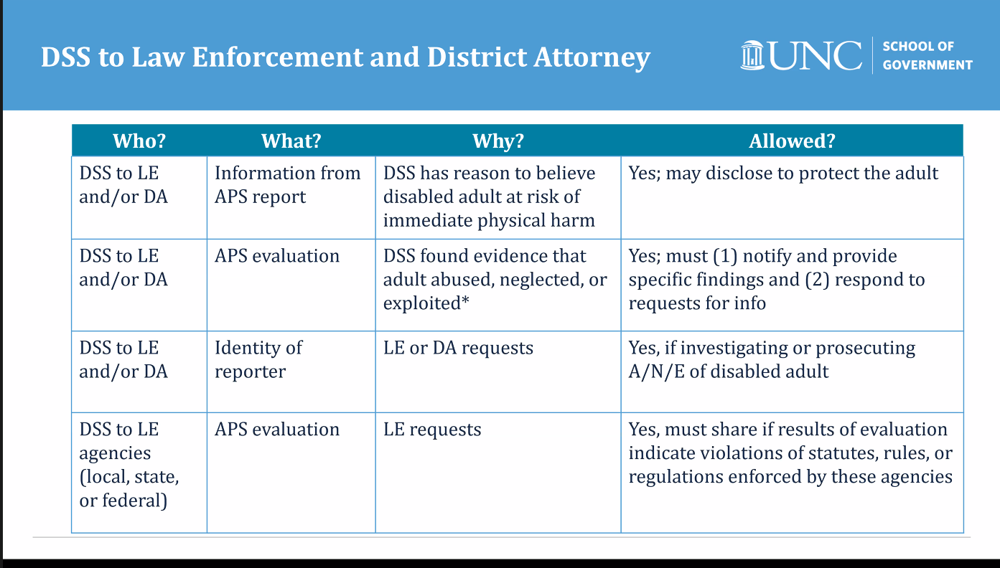
- There is no state law that authorizes information sharing in adult MDT meeting with members. This is different than CPS. MDT-Cannot share client specific information but can if the client consents. De-identifying information is the only way to do that. Keep in mind that APS evaluation findings may be shared as necessary to provide protective service to the adult. If you conclude that sharing information is necessary to help protect them and provide services, then you can.
- May 2022 No. 50 on SOG Social Services Internal Information Sharing resource.
- Kristi Nickodem nickodem@sog.unc.edu; also check out NC Human Services Hub and Coates’ Cannon blog.
Presentation by: Meredith Gregory, Legal Aid of NC, Elder Justice Innovation Grant
Can APS and Legal Aid worked together to help older adults?
- Legal Aid in NC is a non-profit, civil law firm, that represent low-income individuals to ensure equal access to justice
- People can access services either by applying online www.legalaidnc.org , calling 1-866-219-5262 or through the Senior Legal Helpline 1-877-579-7562
- Legal aid of NC has 23 local offices that serve 100 counties
- Poverty level of 187% or lower, but can serve some groups with higher incomes, and target those with the most need.
- Types of cases they handle include housing, government benefits, elder abuse, consumer/debt collection, DV.
- Legal aid does not handle those seeking guardianship, medical malpractice, criminal cases, slip and fall cases or other tort claims.
- Eg. Will help mother seeking a 50B against husband for protection.
- Senior Law Project-8 attorneys across the state only serve people 60 years or older and some specialized issues. All offices serve people 60 and older and around 20% or more of their cases are with this population.
- Senior help line will assist with simple end of life planning like wills, POAs, Elder abuse.
- They are seeking a ACL to improve outcomes.
- They try to assist victims of older abuse with recovering funds or revoking POAs, assist with eviction and foreclosures, debt collection and government benefits. Legal Aid has had an Elder Abuse grant for many years, but their GCC has been reduced.
- Meredith’s contact information: MeredithG@legalaidnc.org
- Questions:
What is the best way to get anyone on the phone at legal aid? We do have a high demand right now. We are looking at chaning our intake system; around 400,000 calls per year.
What are the needs at county level that legal aid could help with? Eviction is a big issue; housing is a need.
Family members or outside people/agenices are filing tax returns for stimulus money on their behalf; we contacted SSA but limited in what we could do to protect them.
They can represent someone who is filing against an adult who believes they are competent; then Legal Aid can assist.
They have brochures; please reach out and they can send that infomration.
Partner Updates:
DHSR/ACLS: Tamara Talbot
- Please keep your notes on your complaint investigations and monitoring. Have a complete file and process for storing these records.
- We are doing a survey for our DSS partners on training needs and runs through February 23, 2024. This will be used for planning our trainings. This was sent out in January.
- Training opportunity: DSS supervisors/managers-on March 6, 2024, 1 to 4 pm. You do not need to register, just click the link. Link forthcoming.
- 3/14/24, from 2-4 pm via TEAMs for AHS, supervisors and PM on Resident discharge rule. She will be sending it out later this week.
- Questions, contact Tamara Talbot or DHSR.Adultcare.Training@dhhs.nc.gov
DAAS: Sarah Richardson
- Monthly survey for January data should be completed by 5 pm on February 14, 2024
- The next SA and Adult Services consultation meeting is February 22; links are found on Sharepoint site and via listserv
- MAC-December data forthcoming in an email. APS/MAC $607,159.14 and MAC standard $509,105.79.
- Change notice on the adult placement manual was sent out on February 1, 2024. Please review this information. It has administrative code and NC General statute information, hyperlinks.
- Annual adult service report for 22-23-sent out Feb 2, 2024.
- The CQI job specialist for region 7 is posted.
- Please make sure to complete the monthly survey’s that is where the bulk of this information comes from.
- APS, Guardianship and SA will be relocating to NC DSS Division on March 1, 2024 in an effort to provide better support to counties.
DMH: Lisa Jackson:
Link recording for the January State CFAC Meeting that contains the agenda and the recording, which includes the discussion with the four LME/MCO CEOs: Joy Futrell from Trillium Health Resources, Rhett Melton from Partners Health Management, Tracy Hayes from Vaya Health and Rob Robinson from Alliance Health. The CEO presentation recording begins in the afternoon around the 12:30 pm point.
Link: https://www.ncdhhs.gov/divisions/mental-health-developmental-disabilities-and-substance-use-services/councils-and-committees/state-consumer-and-family-advisory-committee-meetings#July2023-June2024-4913
- With the dissolution of Sandhills Center and Eastpointe merging with Trillium Health Resources, the consolidation of providers and members/recipients occurred on 2/1/2024. All of the Eastpointe Counties and Sandhills Center counties are now under Trillium Health Resources with the exception of three counties who opted to go with the three remaining LME/MCOs:
- Harnett County went with Alliance Health
- Davidson County went with Partners Health Management
- Rockingham County went with Vaya Health
- I will send the Co-Chairs a new map for sharing that shows the four LME/MCOs and the counties that they cover, as well as a listing of this same information and important phone numbers for each one.
- TP Readiness Re-reviews (virtual) will be happening with the LME/MCOs in March and will focus on items that have either been changed or added since the previous on-site review that need to be reviewed prior to TP go live. Tailored Plan is scheduled for 7/1/2024.
- Roadmap to Strengthen North Carolina’s Caregiving Workforce:
North Carolina leaders released a new report on the state’s caregiving workforce (link to the report: https://www.ncdhhs.gov/investing-north-carolinas-caregiving-workforce- recommendations-strengthen-north-carolinas-nursing/download?attachment) announcing the next steps in strengthening this critical group of workers. The report comes from the Caregiving Workforce Strategic Leadership Council, a group convened by the North Carolina Department of Health and Human Services and the North Carolina Department of Commerce of leaders from government agencies, educational institutions and other key organizations deeply engaged in health care. The new report offers a roadmap of initiatives the state will take to strengthen and support its health care workforce.
- Link to the Caregiving Workforce Strategic Leadership Council: https://www.ncdhhs.gov/news/press-releases/2023/03/07/north-carolina-launches-caregiving-workforce-strategic-leadership-council
- NCDHHS Committed to Improving Children’s Behavioral Health, Announces Details of New Children and Families Specialty Health Plan: Link to the press release: https://www.ncdhhs.gov/news/press-releases/2024/01/17/ncdhhs-committed-improving-childrens-behavioral-health-announces-details-new-children-and-families
- One of the key initiatives is the Children and Families Specialty Plan — a first of its kind statewide health plan to ensure access to comprehensive physical and behavioral health services for Medicaid-enrolled children, youth and families served by the child welfare system. NCDHHS today released an updated policy paper about the plan, as NCDHHS prepares to launch the plan later this year.
- Link to the updated policy paper: https://medicaid.ncdhhs.gov/documents/children-and-families-specialty-plan-policy-paper/open
- Traumatic Brain Injury Updates: TBI Waiver statewide expansion activity has begun including monthly targeted education sessions for all four LME-MCOs, reforming of the TBI Waiver Advisory Committee and other collaborative efforts between DHB and DMH in preparation for the expansion.
- ASAM 3.3 Clinically Managed Population Specific High Intensity Residential Program for individuals with TBI draft clinical coverage policy will soon be posted for public comment. This is an in-patient residential treatment Waiver for individuals with lived TBI experience who are also experiencing substance use disorder.
- Justice: Re-entry and Reintegration Program for individuals with lived I/DD or TBI experience is projected to expand to additional counties in SFY25 with the support of $2 million from behavioral health funding.
- Brain Injury Association of NC (BIANC) website has been updated to meet the 508 compliance requirements. Information can be accessed in user friendly formats and can also be read in a variety of languages. The BIANC website can be found at: www.bianc.net which also contains free online TBI training modules and other educational materials.
- NC Medicaid Accepting Federally Facilitated Marketplace Eligibility Determination- Effective Feb. 1, 2024
- The Centers for Medicare & Medicaid Services (CMS) is mailing letters to 534,840 North Carolinians based on information provided to HealthCare.gov that indicates they may be eligible for NC Medicaid. With the expansion of Medicaid, more people are eligible, including those ages 19 through 64 years with higher incomes. The letters will arrive in mailboxes on or after Feb. 1, 2024, and will direct individuals to contact HealthCare.gov to update their information currently available in their HealthCare.gov case file. Sample letters are available on the Medicaid website.

- NC Medicaid began accepting Federally-facilitated Marketplace Eligibility Determinations (FFM-D) on Feb. 1, 2024. This change allows the FFM to make the eligibility determination for individuals who apply for coverage through the Federal Marketplace at HealthCare.gov and whose eligibility is determined following modified adjusted gross income (MAGI) rules. This change means NC residents who apply for Medicaid through the Federal Marketplace (HealthCare.gov) and are determined fully eligible for Medicaid by the FFM will no longer require an eligibility determination by the local Department of Social Services (DSS) caseworker. Once NC Medicaid receives notification of eligibility, NC FAST will review the case to determine which full MAGI benefit program the individual qualifies for and will send the appropriate final notice of eligibility to the individual.

Discussion on the LME/MCO consolidation: https://www.ncdhhs.gov/providers/lme-mco-directory

