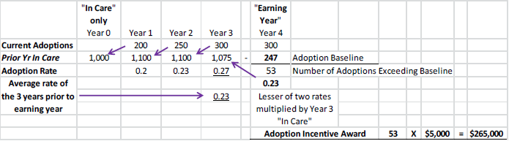

As displayed in the chart, State A finalized 300 foster care adoptions in the earning year (labeled “Year 4”). To determine the number of adoptions qualifying for incentive payments, it is necessary to calculate the base rate of foster child adoptions –the lesser of the foster child adoption rate for the previous fiscal year (Year 3) or the average rate for the previous three fiscal year (Years 1, 2 and 3). In this example, the rate for the immediately preceding FY is determined by dividing the number of adoptions in Year 3 (300 adoptions) by the number of children in foster care on September 30 in the year before that, i.e.,Year 2 (1,110 children in care). Using these numbers, the rate is calculated as follows: 300 ÷ 1110 = (0.27). Following the same approach for each of three previous years, we see that in Year 2 the rate was (0.23) and in Year 1 the rate was (0.20). The average of these three rates is (0.23).

The applicable base rate for determining the foster child adoption incentive is the three-year average (0.23) since it is less than the rate of (0.27) in the year immediately preceding the earning year. This base rate is multiplied by the number of children in foster care on September 30 of the year prior to the earning year (1,075) which yields a baseline foster child adoption number of 247. Subtracting 247 from the number of adoptions in the earning year results in 53 adoptions (300 – 247 = 53) in excess of the baseline number.

To determine the award, we would multiply that number (53) by the dollar amount specified for the foster child adoption category to calculate the overall award for that category. So, since the incentive payment per foster child adoption is $5,000, the total award for the category of foster child adoptions would be $265,000 (53 x $5,000 = $265,000).

